NAME: GURUPRASATH.S
REG NO:192411270L
SUB NAME: COMPUTER VISION
SUB COD: ITA0502
EX NO:4

AIM
To implement histogram equalization on a given image and compare it with the original image using OpenCV.

ALGORITHM
- Start the program.
- Import the OpenCV library.
- Read the input image in grayscale.
- Apply histogram equalization using cv2.equalizeHist().
- Display the original image.
- Display the equalized image.
- Compare the contrast of both images.
- Save the equalized image.
- Stop the program.
PROGRAM:
import cv2

img = cv2.imread("red-lilies-with-changed-background.jpg", 0)

if img is None:
print("Error: Image not found!")
else:
equalized = cv2.equalizeHist(img)

cv2.imshow("Original Image", img)

cv2.imshow("Histogram Equalized Image", equalized)

cv2.imwrite("equalized.jpg", equalized)

cv2.waitKey(0)
cv2.destroyAllWindows()
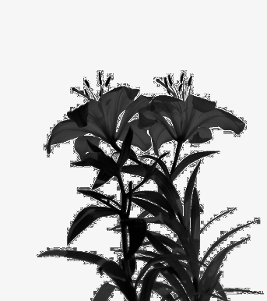
sample input:

SAMPLE OUTPUT:
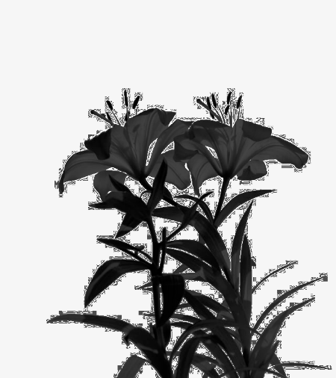

RESULT
Thus, the histogram equalization was successfully implemented using OpenCV, and the contrast of the original image was improved in the equalized image.

